The Impact Of Technology On Education

Submitted By: Ahmeda Fatima

Roll No: FA25-BBA-107

Date: October 2025

2025

Introduction  
In the 21st century, Information and Communication Technology (ICT) has become one of the most powerful tools for human development. It refers to the use of digital technologies such as computers, the internet, mobile phones, and other devices that allow people to access, store, share, and process information. ICT is not limited to personal use—it plays a vital role in education, business, healthcare, communication, and governance.

Importance of ICT  
ICT has transformed the way people interact and live. With the help of the internet and social media, individuals can connect with others across the globe in seconds. In education, ICT makes learning more engaging and accessible through e-books, online classes, and digital libraries. In business, it improves efficiency, reduces costs, and enables global trade through e-commerce.

ICT in Daily Life  
From mobile banking to online shopping, ICT has become part of our everyday lives. People now work from home using telecommunication tools, attend virtual meetings, and access information instantly. In healthcare, ICT assists in storing patient records, diagnosing diseases with advanced technologies, and providing telemedicine services.

# **Benefits of ICT**

* **Fast Communication:** Emails, video calls, and messaging apps allow instant contact.
* **Access to Knowledge:** Online platforms make learning materials easily available.
* **Economic Growth:** ICT creates job opportunities and supports innovation.
* **Improved Services:** Government and private institutions use ICT for better service delivery.

Challenges of ICT  
Despite its advantages, ICT also poses challenges. Issues like cybercrime, data theft, internet addiction, and the digital divide between developed and developing countries need to be addressed.

Conclusion  
ICT is the backbone of modern society. It connects people, spreads knowledge, and drives progress in almost every field. If used wisely and responsibly, ICT can continue to improve our lives and help build a smarter, more connected, and more advanced world.

# References

1. Anderson J. (2010). ICT transforming education UNESCO.
2. Bates, A.W. (2015).Teaching in a digital age .open text book.
3. Kozma, R. (2005).National Policies that connect ICT-Based Education Recall. Asia Pacific Journal of Education.

# Activity 2

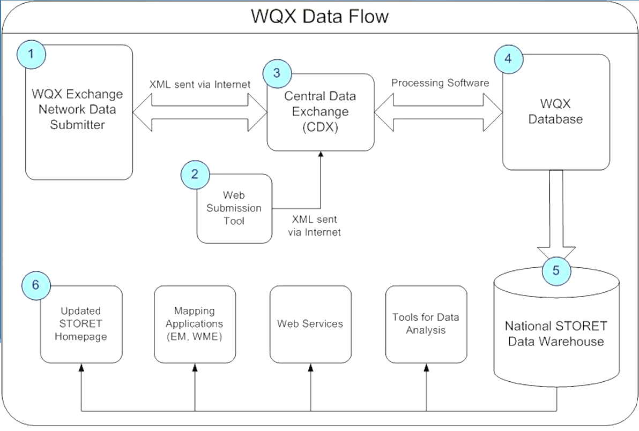

krhw

# Activity 3

